MO Bar’s SUSTAINABILITY EFFORTS

When MO Bar opened its doors in 2005, sustainability was an unfamiliar subject to most. However, with the vision and the leadership of our
Director of Culinary Operations and Food and Beverage, Richard Ekkebus, we set new standards in our operations to ensure that we minimise our harm to the planet, by reducing our environmental footprint and maximising our social impact.

From the get-go, this included such initiatives as serving only sustainable seafood, and supporting charities with causes close to our hearts. Today,
we have constructive, meaningful practices in place focusing on ways to minimise waste, reduce single-use plastic and limit our carbon footprint.

To further improve our practices, in 2021 we started working with
‘Food Made Good’, an organization that provides foodservice businesses with manageable means of understanding, reviewing, and acting on the issues that matter. Within this framework, ten major areas of sustainability are divided under three pillars: Society, Sourcing, and Environment. Accountability is key – our efforts are audited yearly to help us create
a clear plan of action for continuous improvement.

For more information, please scan the QR code below:

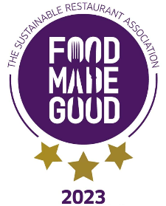
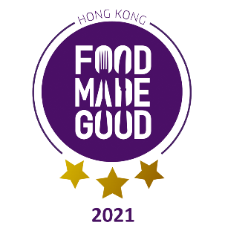

mo bar breakfast sets

the set is designed for individual consumption
for tables with two diners or above, each diner is required to order one individual set
mo bar coffee & croissant  mo bar breakfast set  one cold or hot dish  +  one coffee or tea  +  one juice of choice  full mo bar breakfast set  one cold dish  +  one hot dish  +  one coffee or tea  +  one juice of choice | 118  248  328
full mo bar breakfast feast  one cold dish  +  one hot dish  +  one coffee or tea  +  one juice of choice  +  a glass of champagne | 428

cold dish

signature mo bar red bowl  plain, greek or vegan yogurt with mixed berries, raspberry coulis, granola, chia seed pudding & almonds | 128
breakfast cereals  choice of granola, wheat bran bran or corn flakes  served with cold milk: whole, skimmed, soy, oat or almond milk | 98
home smoked tasmanian salmon  bagel  with cream cheese, cucumber, lettuce, capers & red onions | 128
breakfast basket with a selection of pastries  homemade vegan croissant, pain au chocolat & signature danish  served with buffer & jams | 98
fresh seasonal breakfast fruit  platter | 98

gluten free or can be adapted to suit gluten free diet on request

vegetarian or can be adapted to suit vegetarian diet on request

vegan or can be adapted to suit vegan diet on request

hot dish

organic free-range kin eggs  fried, scrambled, poached, omelette or boiled served  with hash brown, crispy bacon, pork sausage,  roasted roma tomato & toast | 136
eggs benedicts  treacle marinated back bacon or smoked salmon eggs ‘benedict’  english muffin topped with sauteed spinach, two poached eggs &  hollandaise sauce | 128
pancakes  with mango, banana, passion fruit, lime peel & whipped coconut cream | 108
belgian waffle  with strawberry, whipped cream, shaved toasted almonds & maple syrup | 108
dim sum (6pcs)  assorted steamed dim sum served with soy sauce & chili oil | 138
tiger prawn, chicken or minced beef congee  with ginger, iceberg lettuce, spring onions, salted peanuts & crispy youtiao | 108
stir fried noodle  with soy sauce, bean sprouts, cabbage , spring onions & sesame | 108
chicken, chicken broth & rice noodle  with shiitake mushroom, iceberg lettuce & spring onion | 138

gluten free or can be adapted to suit gluten free diet on request

vegetarian or can be adapted to suit vegetarian diet on request

vegan or can be adapted to suit vegan diet on request

beverages

iced tea “the landmark original blend” | 85
milk  whole, skimmed, organic soy  valrhona chocolate milk hot or cold | 60  88

juices

carrot, cloudy apple, grapefruit, mango,  orange, pineapple, watermelon, tomato | 88
japanese juice  white peach  (FOR ALL BREAKFAST SETS, ADD 15) | 103

mineral water

still or sparkling

nordaq fresh, house filtered water  350ml  750ml | 55  85
acqua panna or san pellegrino, italy  250ml  750ml | 78  105

coffees

espresso, macchiato | 78
americano, cafe latte, cappuccino, flat white, cafe mocha  All coffees are available decaffeinated  whole, skimmed, organic soy, oat, almond milk available | 85
french press  single origin brazilian coffee bean tends to be low in acidity, smooth in body with sweet flavors. | 85

black
jing english breakfast | 82
jing earl grey | 82
oolong
osmanthus | 92
puerh
vintage cooked puerh | 82
green

jasmine pearls  japanese sencha | 92  108
white

premium white peony | 104
herbal

whole chamomile flowers | 82
peppermint | 82
lemongrass & ginger | 82

